**Tableau How To**

**Display the aggregate menu for a measure**

* Right click on the measure name and drag over to the column shelf

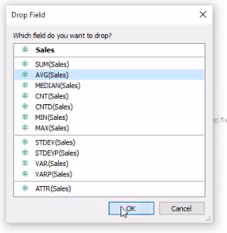

**Drill down to map details and add a back button**

* You can drill down to either a separate worksheet or a separate dashboard but if you use a dashboard then you can add a back button worksheet onto it to go back to the main dashboard.
* Create the details by region or state or city/zip in a separate worksheet or dashboard
* The action is on the dashboard (no focus is needed)
  + Top of dashboard choose Dashboard tab – Actions – Add Action – Filter
  + Name filter Map
* In the Add Filter Action Box
  + Source sheet choose Select – Uncheck all worksheets except Map
  + Target sheet choose map drilldown worksheet or dashboard
    - Show all values
  + OK

BACK BUTTON

* Is manually created in a separate worksheet
  + New version of Tableau offers a button object but the ne server is also needed to use it
* Create button worksheet
  + Add button worksheet to the drilldown dashboard you created
  + Add action on button back to the main dashboard

**Show empty string instead of NULL**

**Refresh Extract**

* Go to main worksheet
* Right click on the data source
* Extract – Refresh extract

**Conditional Formatting Text**

* Create calculated field and place on color

IF(COUNT([ReAdmit]) <=2) then "RED"

ELSEIF(COUNT([ReAdmit]) <=5) then "YELLOW"

ELSE "GREEN"

END

<https://www.youtube.com/watch?v=iEbx-tgR-bA>

<https://www.youtube.com/watch?v=YBt37jvOQ7g&t=8s>

**Conditional Formatting Background**

**How to clear all filters**

* Only works in Tableau Server
* After setting and applying filters to get back to original no filter settings
  + On top left click “Revert”

**How to add a floating logo to title bar**

* Choose Floating under objects
* Then drag the image object on top of the dashboard
* Re-size, save

**How to use multiple data sources with different worksheets**

* Connect to the primary data source as usual.
* Create a Worksheet. This Worksheet will utilize data from your first data source.
* Create a new Worksheet.
* Using the top menu bar, select**Data** > **New Data Source**.
* Connect to a new data source (and if necessary, drag the tables into the (empty) data relationship window). If you like, you can navigate back to the most recently created Worksheet to see fields from the new data source available for use.
* When building views in your worksheets, it is important to use one data source per worksheet to prevent blending.
* If you use fields from multiple data sources in the same worksheet, Tableau will automatically look for a linking field to use for data blending.

**How to save Extract dashboard as a package**

* Update data and choose extract
  + You may have to delete the old extract if getting corrupt data
* Save Extract then save as package
* File-Save as type .twbx

**How to delete extracts**

* Documents – Tableau repository- data sources
* Delete extract
* Or right click inside workbook on table connection – extract - remove

**How to Create Relationship between Different Data Sources**

* Click on worksheet
* Data – Edit Relationships – Custom – Add Relationship

**How to Set Up a Toggle to Switch Worksheets**

**NOTE: Use a floating horizontal or vertical container behind any chart I want to float (see video)**

<https://community.tableau.com/message/830099#830099>

https://www.youtube.com/watch?v=FVPJResyDrY&t=717s

* Create two worksheets
* WORKSHEET 1
* Create integer parameter called Toggle
  + Data Type = Integer
  + Available values = List
  + Value = 1,2
  + Display as = Name my worksheets I want to toggle
* Create a calculated field to control the parameter
  + Call it Toggle Filter
  + Enter the parameter name in the filter only
  + Place the calculated field into the dimensions section
  + Set the parameter to “Show Parameter”
  + Place the Calculated Field in the Filter section from the dimensions section
  + Choose Select from a list – check 1 – apply – ok
* WORKSHEET 2
  + Show parameter but point it to the second worksheet
  + Set filter to point to worksheet 2
* How to get the parameter to show in the Dashboard
  + Analysis – Parameters – Choose parameter
* DASHBOARD
  + Might be better to create a vertical or horizontal layout first.
  + Overlay each worksheet over each other on the dashboard
  + This takes some practice
* Make sure all dashboard filters are working for each toggled worksheet.

**How to hide the “abc” measure column**

**NOTE(This worked, but other solutions worked in the worksheet but did not propagate to the dashboard)**

* **This worked**
* Place the last column dimension pill next to the total column into the TEXT box
  + You will see the same data in two columns now
* Uncheck “Show Header” on the pill in Rows for the source column
* Rename the new column by right clicking in Column section on top and choose new calculation
* Enter title in double quotes i.e. “New Title”
* Hide the old title
* Resize the last column

**How to Stop the Field Values from bunching up in the first Column under one field name**

* Go to Analysis - Table Layout – Advanced
  + Enter a higher number of rows and columns i.e. 16

**Incrementally re-size a map**

* Use the mouse roller instead of the map legend plus and minus

**How to Publish PowerPivot to Tableau Server**

* Tableau Server does not support publishing a PowerPivot file from a local file but it does support publishing a PowerPivot file from SharePoint
* The process would be
  + Develop PowerPivot in Excel
  + Deploy to Sharepoint
  + Deploy to Tableau from SharePoint
  + Publish to Tableau Server from Tableau

**NOTE:** PowerPivot 2013 requires SharePoint 2013 or higher and SQL Server Enterprise edition

**Below is how to log into SharePoint from Tableau**

**Link - https://connectevps.envisionhealth.com/depts/qual/Quality%20Reporting** 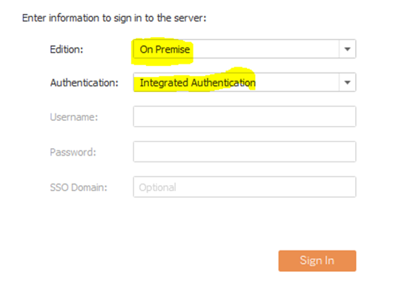

**Log Into Tableau Server**

* Enter tableau.shcr.com
* Sign In

**Create Cascading Filters**

* Drag dimensions needed into the Filters pane.
* Right click and choose show filter
* On the drop down choose “Only Relevant Values”

**Create a Date Range single Filter**

* Slide the Date dimension into the Filters pane
* Choose next
* Choose Range of Dates
* Apply ok
* Right click and choose Show filter
* Adjust filter as needed

**Create Start and End Date Parameters**

Step 1: Create Start Date and End Date Parameters

1. In the Data window, click the drop-down arrow at the top right of Dimensions, and then select **Create**> **Parameter**.
2. In the Create Parameter dialog box, name the parameter. In the example workbook, the parameter is named **Start Date**.
3. Under Data Type, select **Date & time**.
4. UnderAllowable values, select **Range**.
5. Click **Set from Field** and select the date field. In the example workbook, the date field is named **Order Date**.
6. Click **OK**.
7. Right-click the **Start Date** parameter and then select **Show Parameter Control**.
8. Repeat steps 1-7 to create the **End Date** parameter.

Step 2: Create a Date Range Calculation

1. Right-click **Order Date** in the Dimensions pane and then select **Create** > **Calculated Field**.
2. Name the calculated field **Date Range**, and type the following in the **Formula** window, and then click **OK**:

[Order Date] >= [Start Date] AND [Order Date] <= [End Date]

Step 3: Add Date Range to Filters

1. Drag **Date Range** to **Filters**, select **True**, and then click **OK**.
2. Right-click **Date Range** on the **Filters** shelf, select **Apply to Worksheets**, and then select **All Using this Data Source**.

**PARAMETERS**

* How are parameters used
  + After creating a parameter it will do nothing unless you use it in one of the following:
    - Calculated field
    - Reference line
    - Filter
    - Set

How To Create a Multi-Valued parameter list with ALL option

* Cannot use the Parameter for this
* Drag the Doctor dimension into the filters pane
* Choose Show Filter
* On filter drop down choose “Multiple Values List”

How to create a parameter list to choose from with ALL option

* Create a parameter
  + i.e. Doctor List
  + Enter All in the first row
  + Choose “Add from Field
  + Choose appropriate field
* Create a calculated field referencing the parameter
  + Filter Doctors
    - [Doctor List] ="All"
    - OR CONTAINS([Doctor List],[Doctor])

How to build a dual access chart